**Docker Setup:**

Prerequisites: - OS-64 bit

Windows 7 or higher

Click on virtual machine platform.

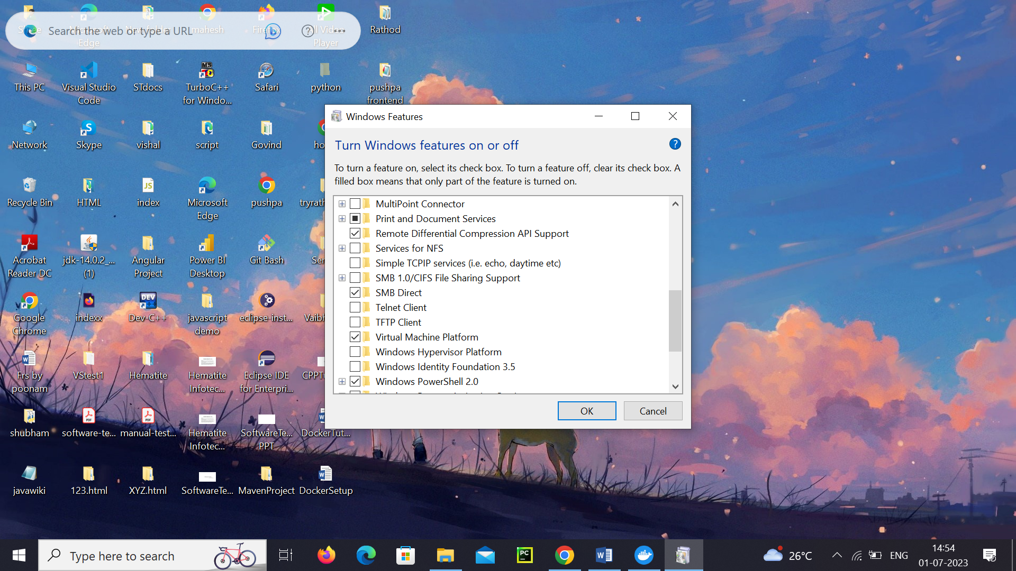

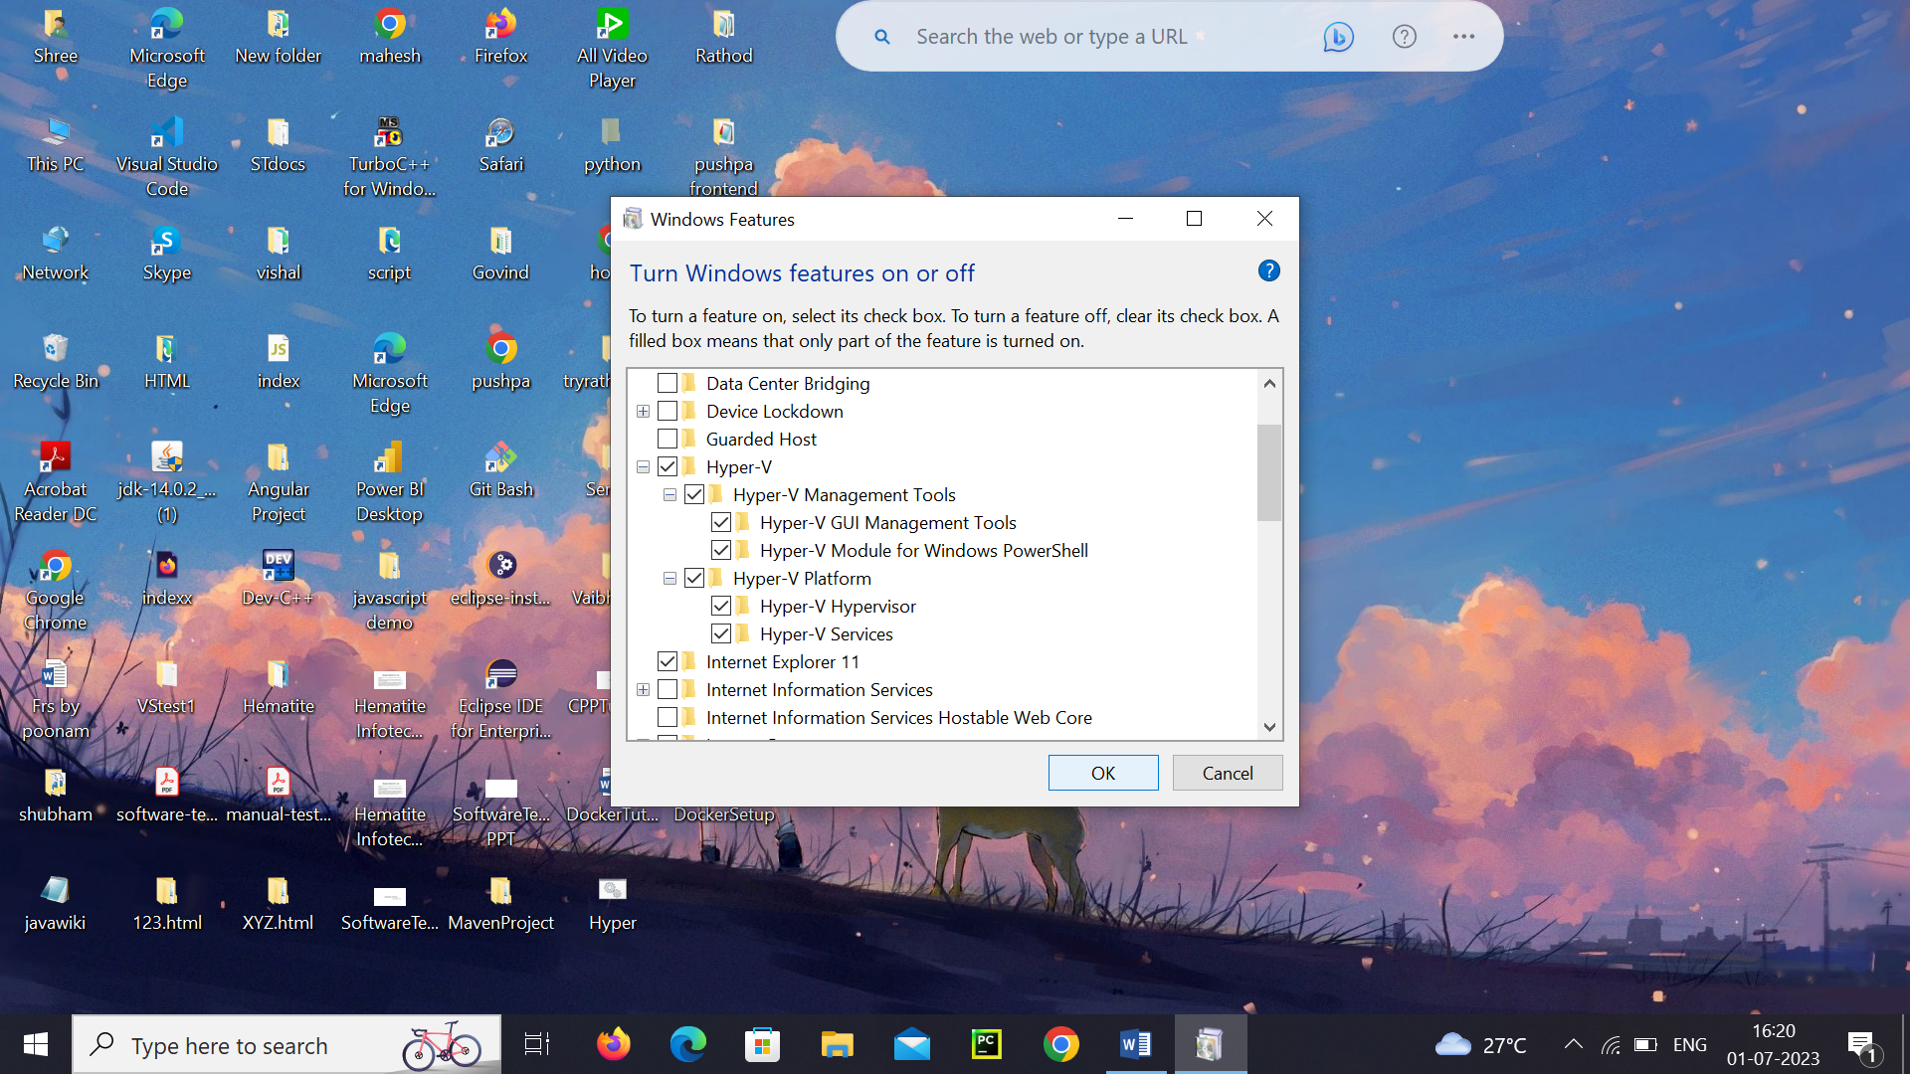

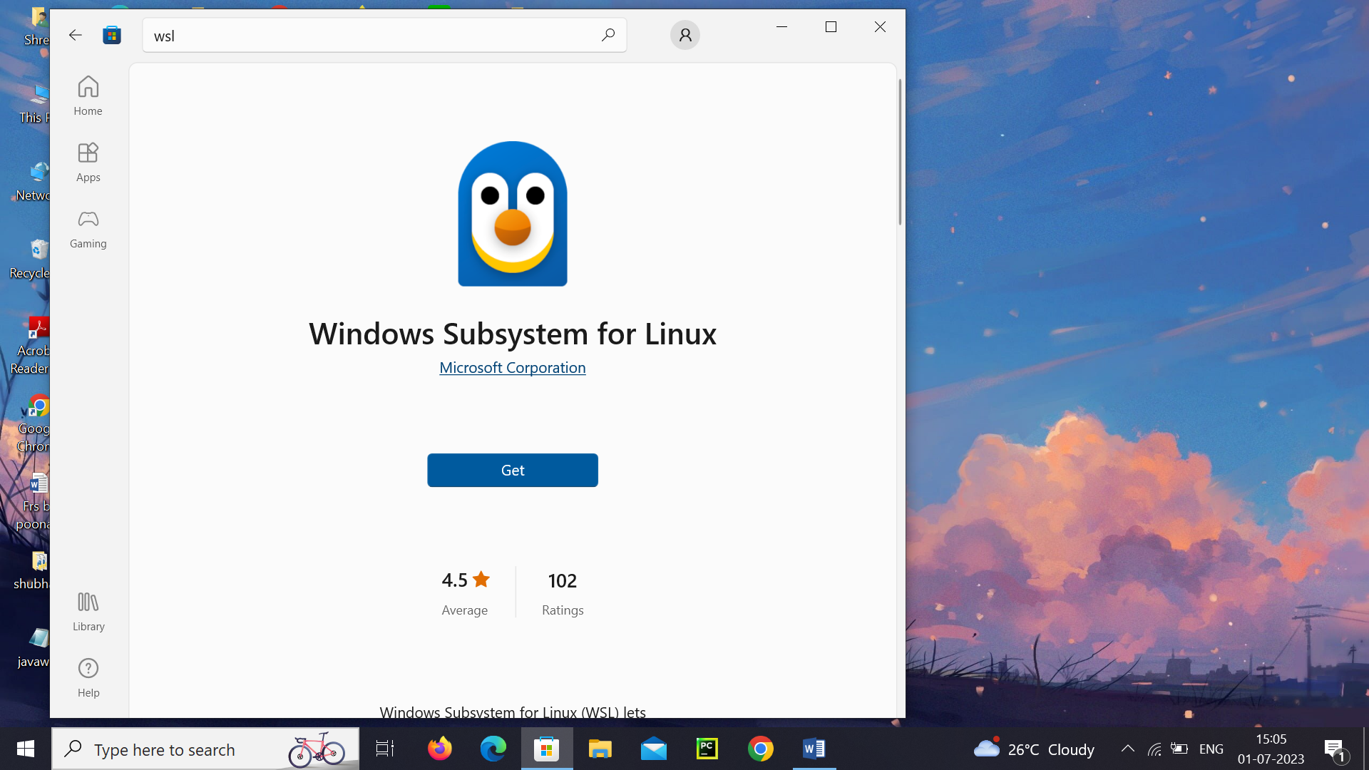

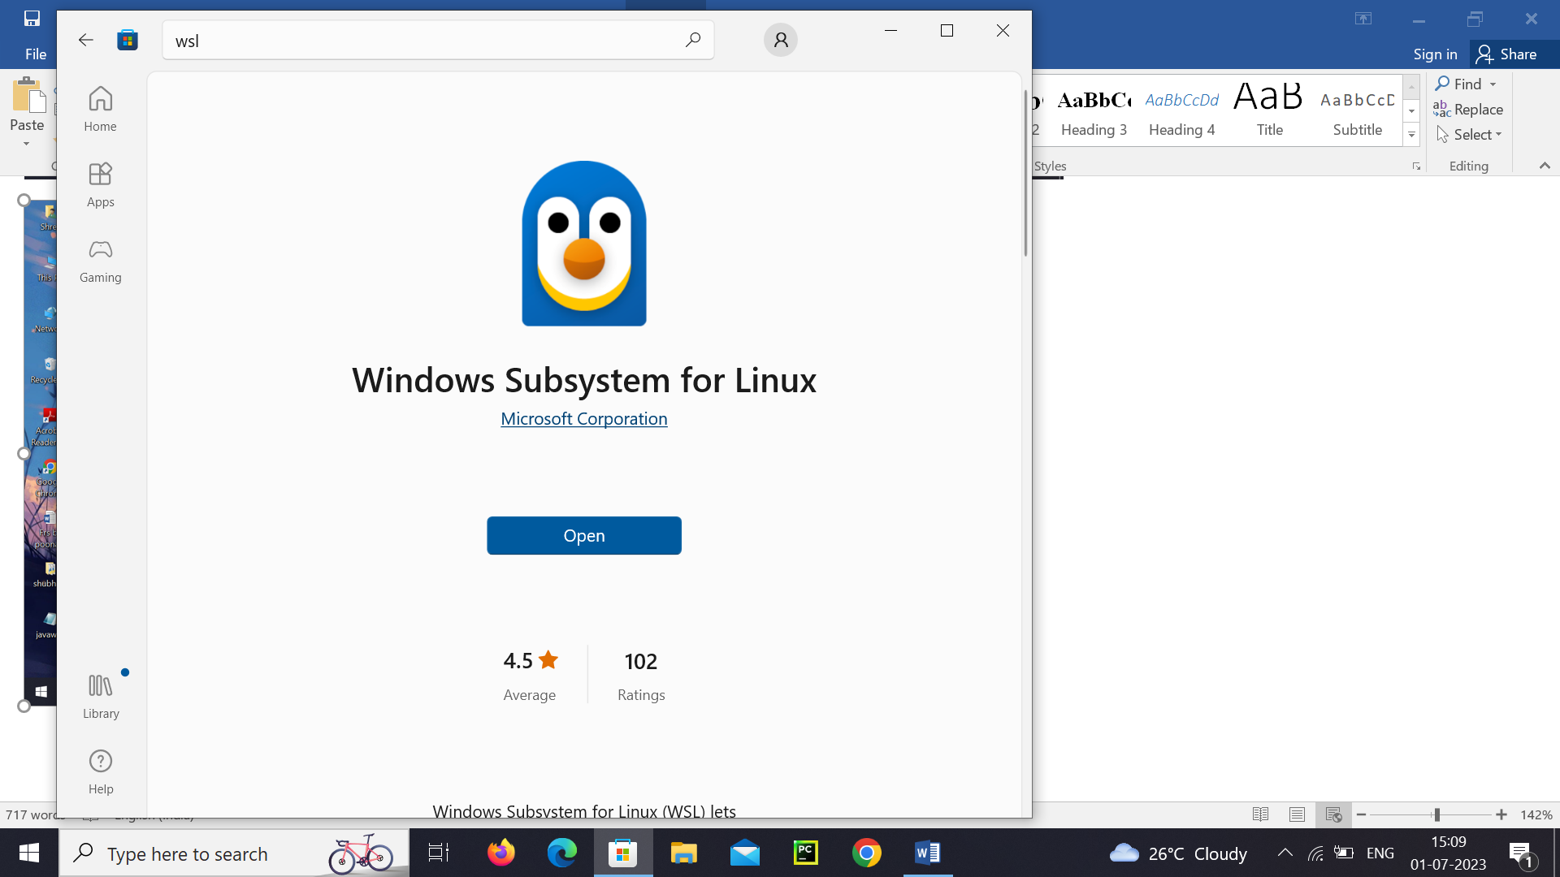

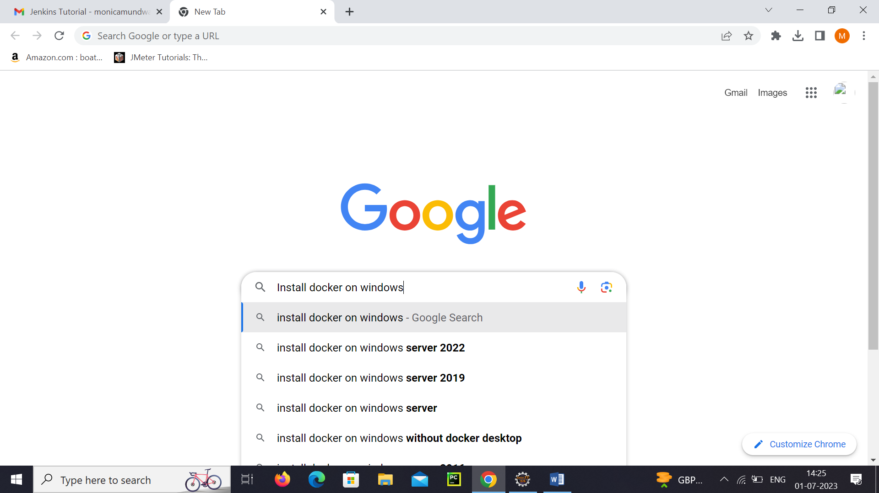

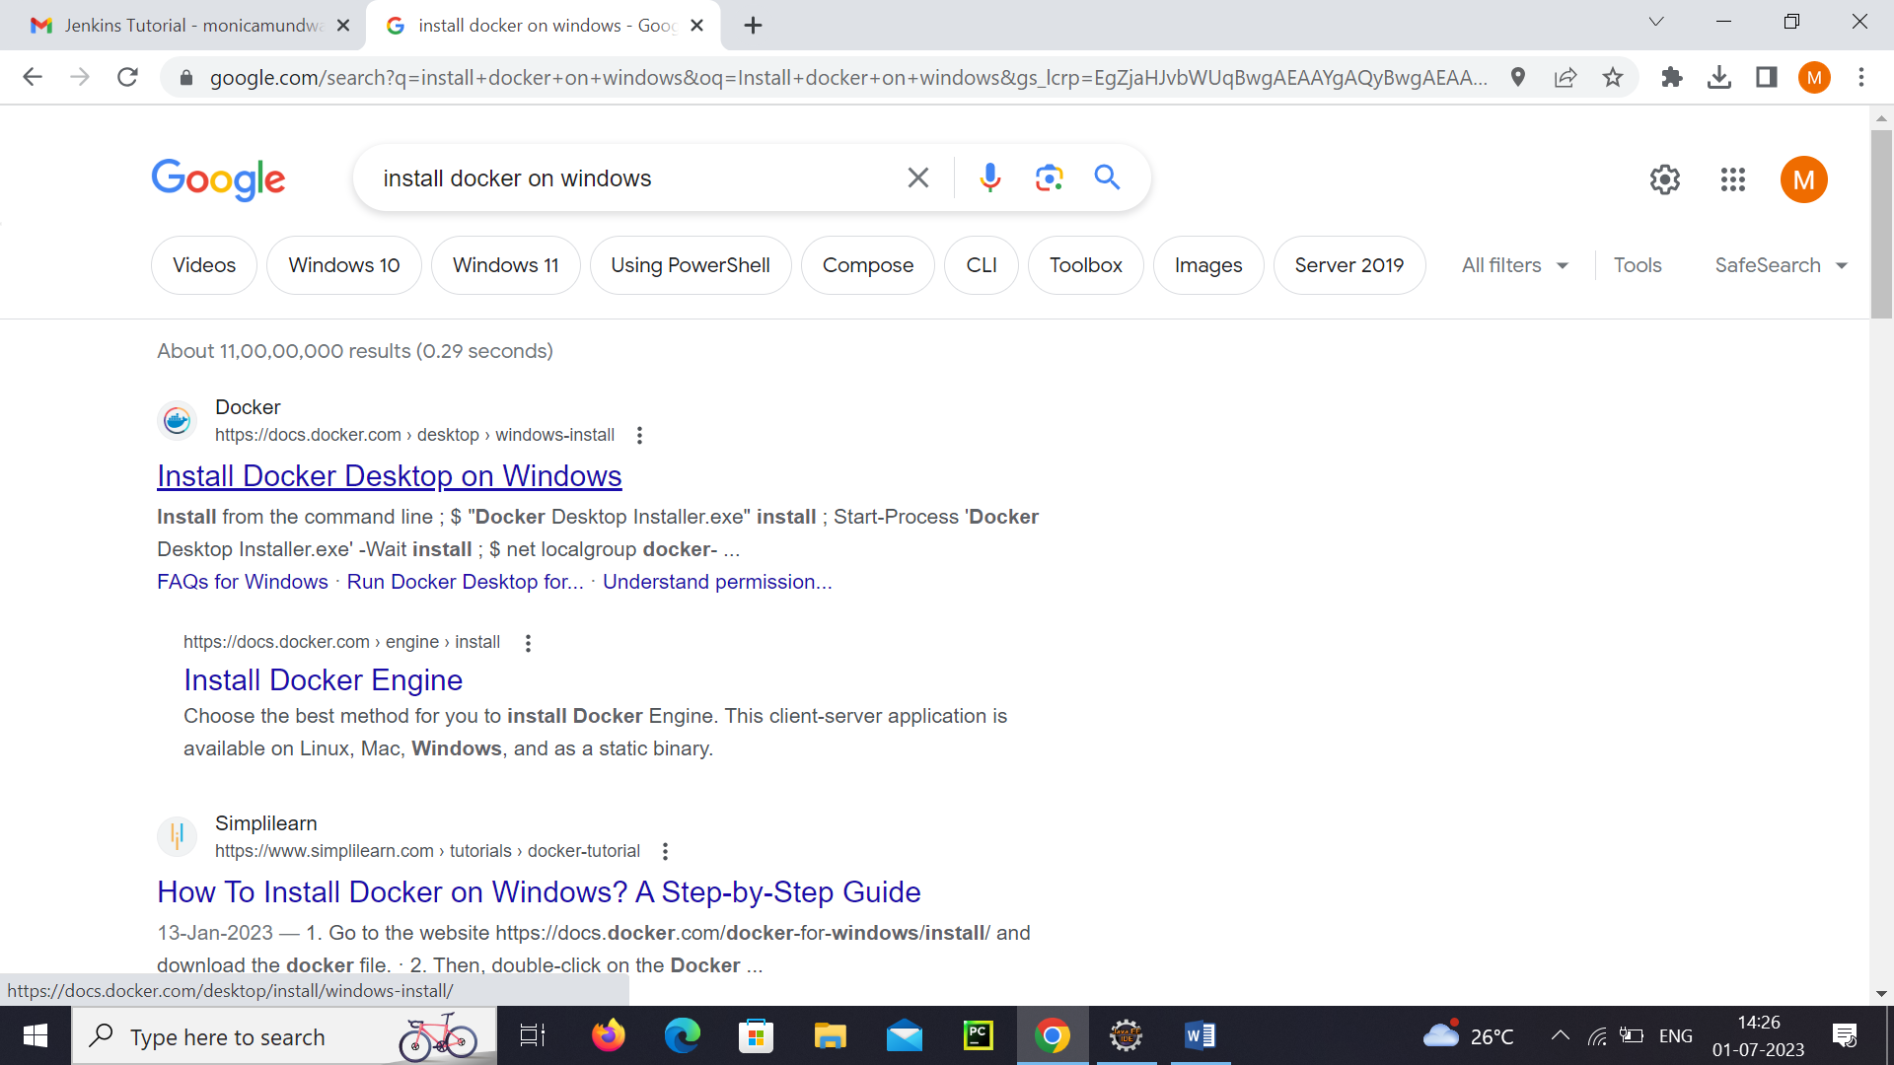

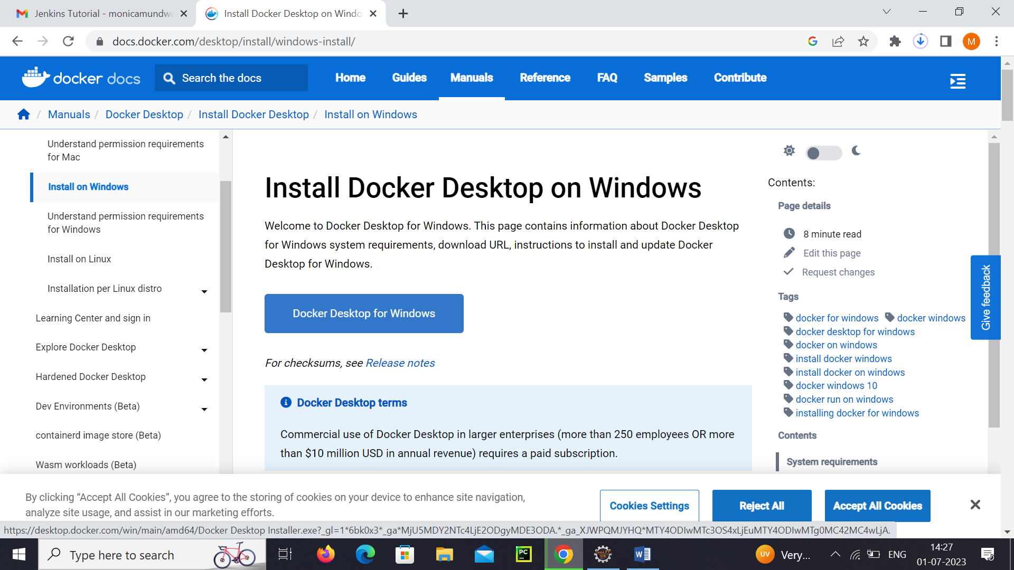

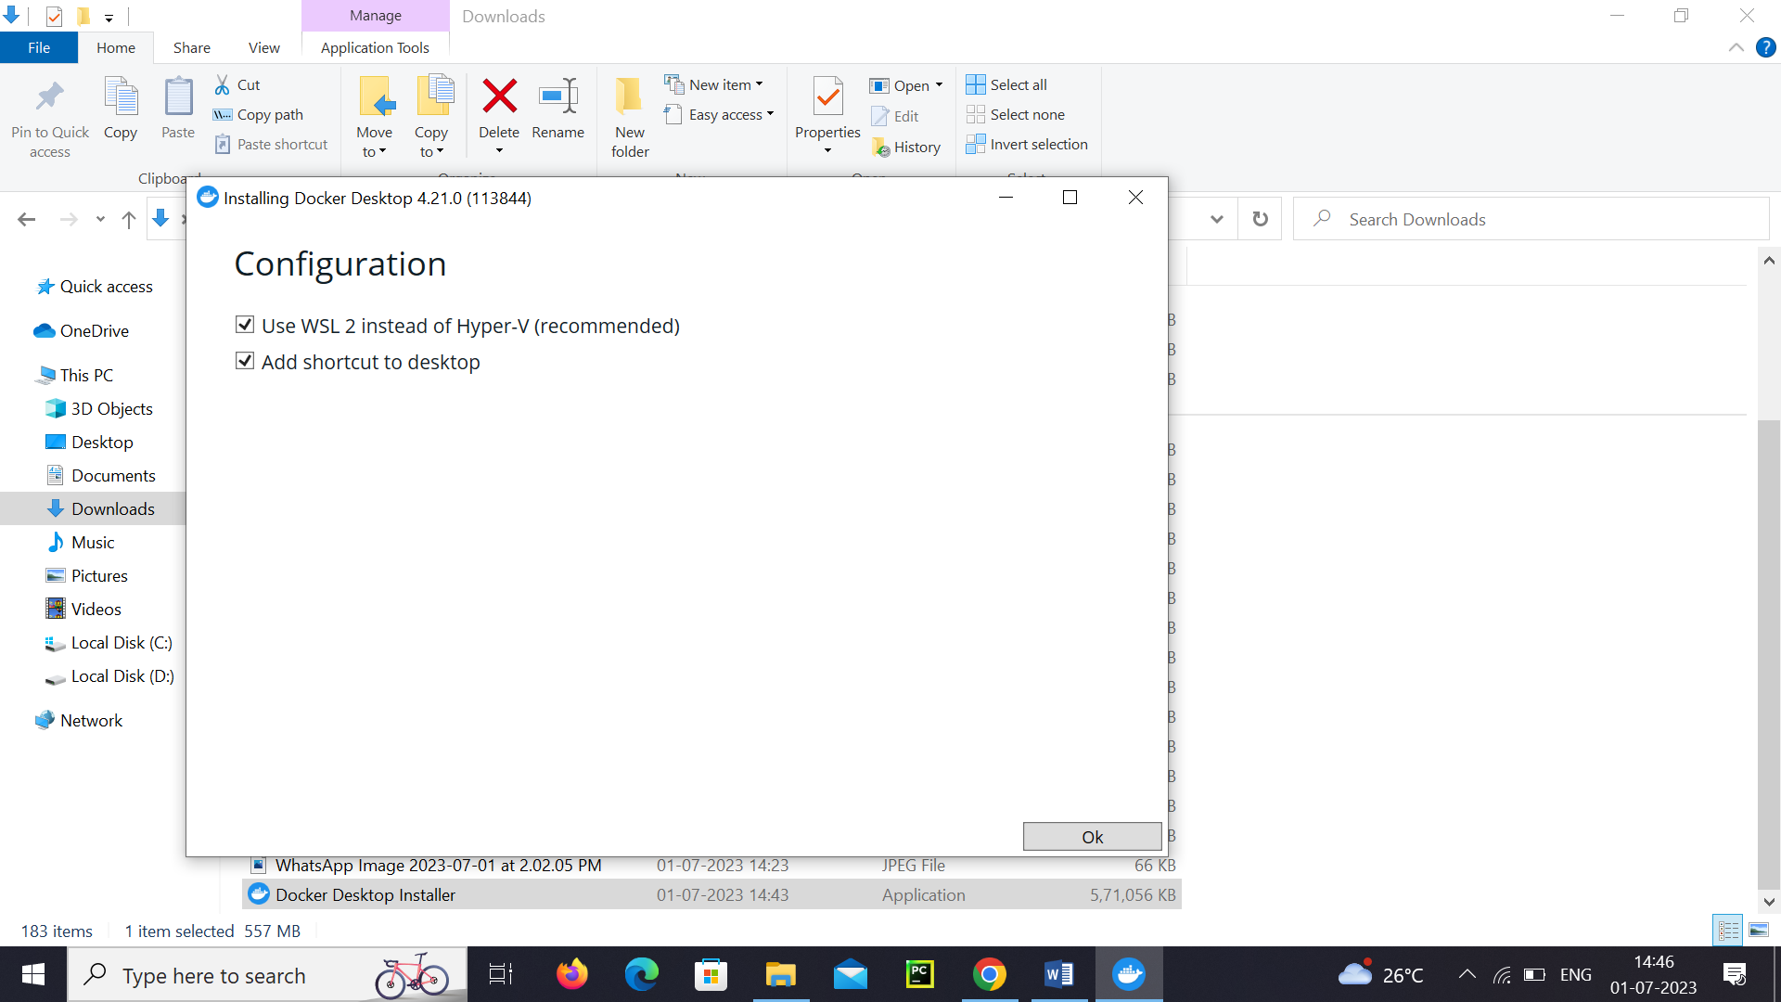

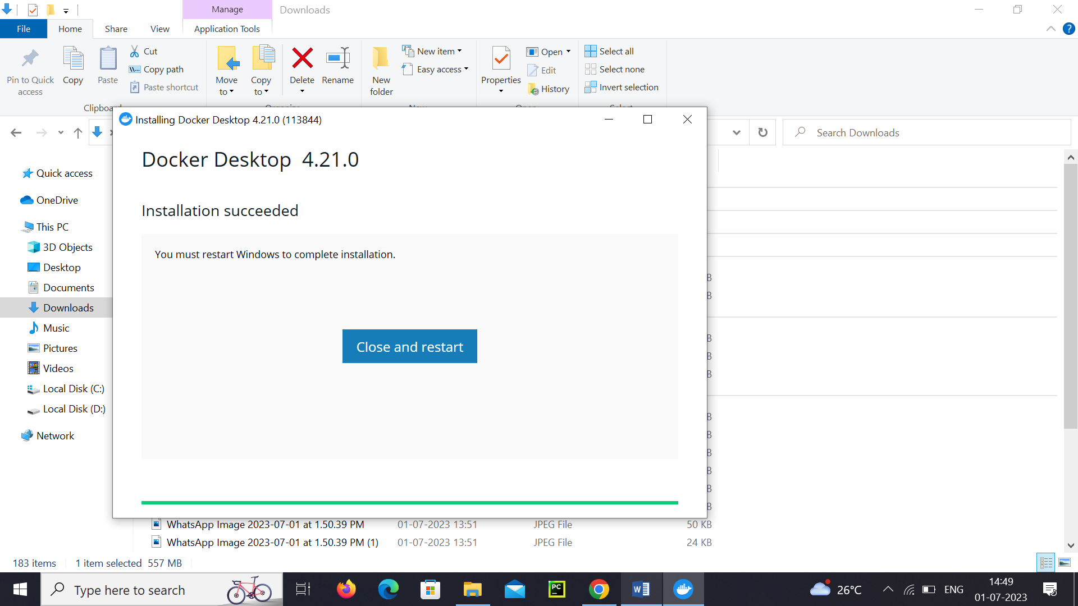

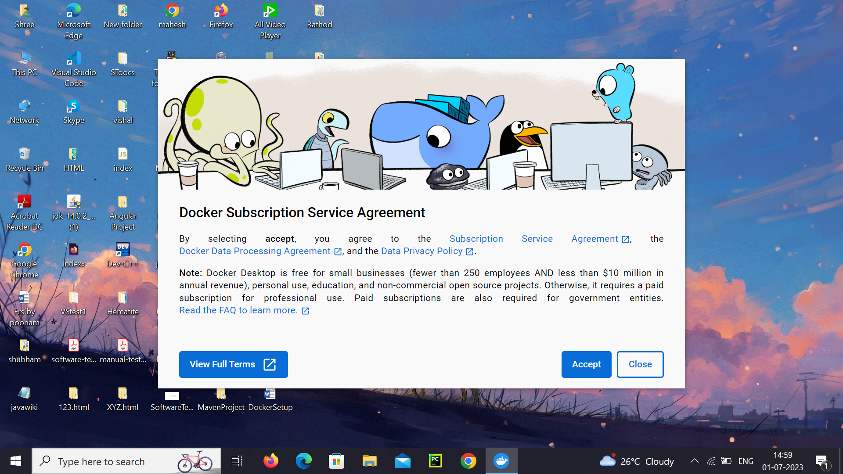

Install Docker Desktop on Windows

Install interactively

1. Double-click **Docker Desktop Installer.exe** to run the installer.

If you haven’t already downloaded the installer (Docker Desktop Installer.exe), you can get it from [**Docker Hub**](https://hub.docker.com/editions/community/docker-ce-desktop-windows/). It typically downloads to your Downloads folder, or you can run it from the recent downloads bar at the bottom of your web browser.

1. When prompted, ensure the **Use WSL 2 instead of Hyper-V** option on the Configuration page is selected or not depending on your choice of backend.

If your system only supports one of the two options, you will not be able to select which backend to use.

1. Follow the instructions on the installation wizard to authorize the installer and proceed with the install.
2. When the installation is successful, click **Close** to complete the installation process.
3. If your admin account is different to your user account, you must add the user to the **docker-users** group. Run **Computer Management** as an **administrator** and navigate to **Local Users and Groups** > **Groups** > **docker-users**. Right-click to add the user to the group. Log out and log back in for the changes to take effect.

Install from the command line

After downloading **Docker Desktop Installer.exe**, run the following command in a terminal to install Docker Desktop:

$ "Docker Desktop Installer.exe" install

If you’re using PowerShell you should run it as:

Start-Process 'Docker Desktop Installer.exe' -Wait install

If using the Windows Command Prompt:

start /w "" "Docker Desktop Installer.exe" install

The install command accepts the following flags:

* --quiet: Suppresses information output when running the installer
* --accept-license: Accepts the [Docker Subscription Service Agreement](https://www.docker.com/legal/docker-subscription-service-agreement) now, rather than requiring it to be accepted when the application is first run
* --no-windows-containers: Disables the Windows containers integration
* --allowed-org=<org name>: Requires the user to sign in and be part of the specified Docker Hub organization when running the application
* --backend=<backend name>: Selects the default backend to use for Docker Desktop, hyper-v, windows or wsl-2 (default)
* --installation-dir=<path>: Changes the default installation location (C:\Program Files\Docker\Docker)
* --admin-settings: Automatically creates an admin-settings.json file which is used by admins to control certain Docker Desktop settings on client machines within their organization. For more information, see [Settings Management](https://docs.docker.com/desktop/hardened-desktop/settings-management/).
  + It must be used together with the --allowed-org=<org name> flag.
  + For example: --allowed-org=<org name> --admin-settings='{"configurationFileVersion": 2, "enhancedContainerIsolation": {"value": true, "locked": false}}'
* --proxy-http-mode=<mode>: Sets the HTTP Proxy mode, system (default) or manual
* --override-proxy-http=<URL>: Sets the URL of the HTTP proxy that must be used for outgoing HTTP requests, requires --proxy-http-mode to be manual
* --override-proxy-https=<URL>: Sets the URL of the HTTP proxy that must be used for outgoing HTTPS requests, requires --proxy-http-mode to be manual
* --override-proxy-exclude=<hosts/domains>: Bypasses proxy settings for the hosts and domains. Uses a comma-separated list.
* --hyper-v-default-data-root=<path>: Specifies the default location for the Hyper-V VM disk.
* --windows-containers-default-data-root=<path>: Specifies the default location for the Windows containers.
* --wsl-default-data-root=<path>: Specifies the default location for the WSL distribution disk.
* --always-run-service: Lets users switch to Windows containers without needing admin rights.

If your admin account is different to your user account, you must add the user to the **docker-users** group:

$ net localgroup docker-users <user> /add

Start Docker Desktop

Docker Desktop does not start automatically after installation. To start Docker Desktop:

1. Search for Docker, and select **Docker Desktop** in the search results.
2. 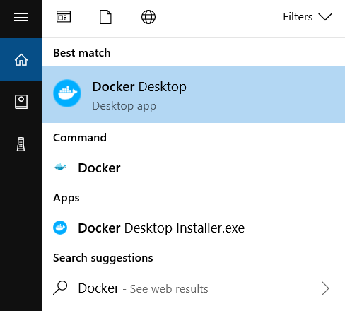
3. The Docker menu () displays the Docker Subscription Service Agreement window.

Here’s a summary of the key points:

* + Docker Desktop is free for small businesses (fewer than 250 employees AND less than $10 million in annual revenue), personal use, education, and non-commercial open source projects.
  + Otherwise, it requires a paid subscription for professional use.
  + Paid subscriptions are also required for government entities.
  + The Docker Pro, Team, and Business subscriptions include commercial use of Docker Desktop.

1. Select **Accept** to continue. Docker Desktop starts after you accept the terms.

Note that Docker Desktop will not run if you do not agree to the terms. You can choose to accept the terms at a later date by opening Docker Desktop.

For more information, see [Docker Desktop Subscription Service Agreement](https://www.docker.com/legal/docker-subscription-service-agreement/). We recommend that you also read the [FAQs](https://www.docker.com/pricing/faq).